**线索卡与证人证言卡中英对照**

* ...was not transported by...

...不是用...交通工具运走的

* ...was not at (the) ...

...不在...这个时间（或犯罪现场）

* ...killed with...

...用...这个凶器杀人

* ...killed at ...

...在...这个时间（或犯罪现场）杀了人

* ...did not kill at...

...在...这个时间（或犯罪现场）没有杀人

* ...did not kill with...

...没用使用...凶器杀人

* the perpetrator was wearing jewelry at...

在...时间的杀人犯当时佩戴着珠宝

* the perpetrator was not bearded at...

在...时间的杀人犯当时没有胡子

* the perpetrator was wearing headgear at...

在...时间的杀人犯当时佩戴着帽子

* ...was (not) the murder weapon at ...

...(不)是...这个时间(或犯罪现场)的凶器

* ...was (not) the crime scene at...

...(不)是...这个时间的犯罪现场

* The getaway vehicle was not ... at...

在...这个时间逃跑的车辆不是...颜色的

* ...did not kill right before/after...

...没有在...之前/后杀人

* ...was (not) the murder weapon (directly) before ...

...(不)是...之前的杀人凶器

* Between the murder at ... & ... exactly ... minutes passed.

在...与...两个犯罪现场的谋杀案之间刚好相距...分钟

* Between the murder by ... & ... exactly ... minutes passed.

在...和...两人的谋杀案之间正好相距...分钟。

* Between the murder with ... & ... exactly ... minutes passed.

在使用...和...两凶器的谋杀案之间正好相距...分钟。

* Between the escape by ...&... Less than ... minutes passed

...与...两辆汽车之间的逃逸相距时间不到...分钟

* ...was the getaway car before/after...

...是在...之前/后逃跑的小车。

* ...did not murder with...

...没有用...杀人

* ...did not murder at ...

...没有在...这个时间杀人

* ...was not the getaway vehicle at...

...不是在...这个时间的逃跑车辆

* ...killed before...

...在... 之前杀了人

* ...was a crime scene before / after...

...在...之前/后成了犯罪现场。

* ...was not used at ...

...在...这个时间未使用

* A man killed at ...

一个男人在...这个时间（或犯罪现场）杀了人

* A male perpetrator killed at...

在...这个时间的杀人犯是一名男性。

* A person wearing headgear killed with ...

一个戴头套的人用....杀了人

* A person with blond hair killed with ...

一个金色头发的人用...杀了人

* A person without eyeglasses killed at ...

一个带眼镜的人在...这个时间（或犯罪现场）杀了人

* A person older than ... years old killed with...

一个年龄在...岁以上的人用...杀了人。

* ...fled with less than ... golf clubs in the trunk

...离开时后备箱里的高尔夫球杆少于...个

* ...fled with more than ... golf club in the trunk

离开时后备箱里的高尔夫球杆不止...个

* ...did not flee with two golf clubs in the trunk

...没有开着后备箱有两个高尔夫球杆的车逃离

* ... did not flee with ...

...没有开...这辆车逃离

* ... fled with...

...开着...这辆车逃离了

* The product of all digits ends with ...

所有数字的乘积以...结尾

* Two digits of the license plate add up to ...

车牌号的两个数加起来最多是...

* Upside down the numer is ...

颠倒后数字是...

* in the mirror you can see the number ...

在镜子里你可以看到数字...

* Multiplying any two of the digits never results in ...

任意两个数字相乘不会得到...

* Part of the license plate looks like this:...

车牌的一部分是这样的：...

* The upper part of the license plate looks like this:...

车牌的上半部分是这样的：...

* The number can be divided by ....

这个数可以被...除

* Upside down it spells out...

倒过来拼出的是....

* adding up two of the digits and subtracting the other tow makes an even number.

把其中两个数字加起来，再减去另外两个数字得到是偶数

* the digits of the number have 16 strokes

车牌的数字“笔画”共有16画

*译者注：这里指的笔画数，不是我们日常的书写笔画，而是电子计时器笔画数。举例如下：*

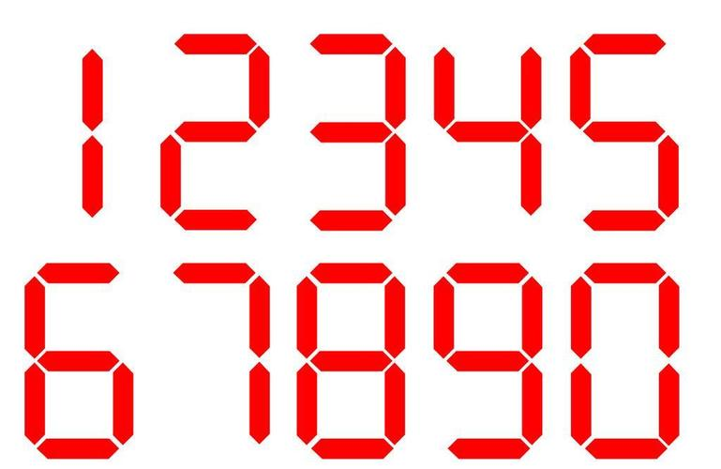

*如：“1”——2画，“2”——5画，“8”——7画*

*“1234”——2+5+5+4=16画*

* Adding up three of the digits and subtracting the fourth makes...

将其中的三个数字相加并减去第四个数字得到...

* Exactly two digits can be turned upside down without changing them.

两个数字正好可以颠倒而不改变它们

* One digit is four times another digit on the license plate.

车牌上的一个数字是另一个数字的四倍。

* The sum of three of the digit is...

三个数字的和是...

* The lower Part of the license plate looks like this:...

车牌的下半部分是这样的：...

* Multiplying two of the digits makes 21

两个数字相乘得到 21

* If you switch the ... and... digit, the number gets bigger.

如果交换第...和第...位数字，数字会变大。